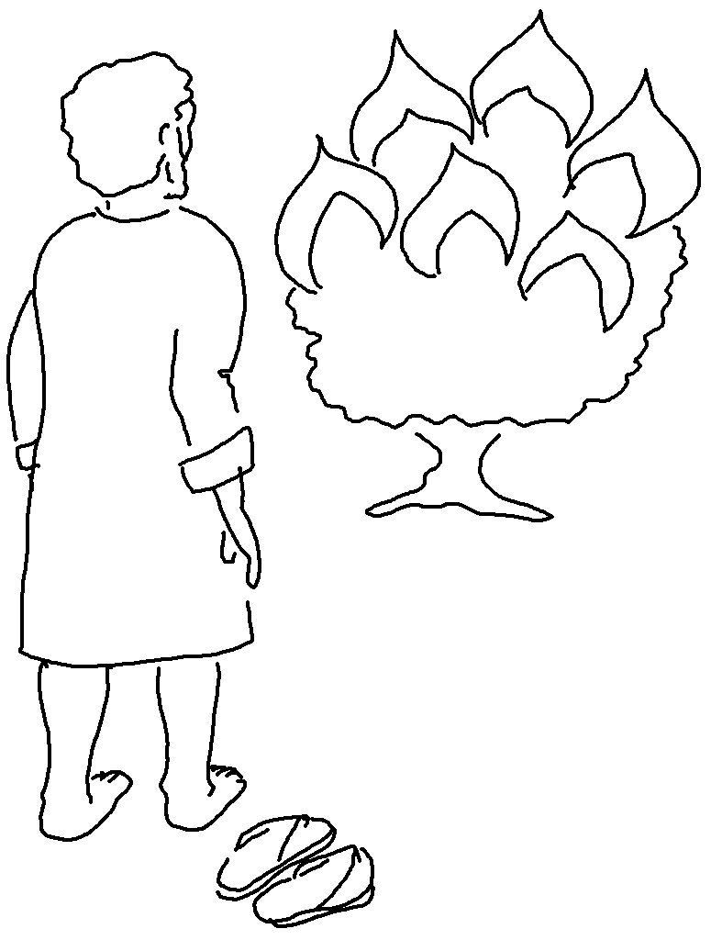
Come, let us worship… Let us kneel before the Lord… Psalms 95:6_{NLT}

